ADEYEMI ADESHOLA KEHINDE
Retail Sales Analysis – SQL Project

Step 1: Importing the Dataset
I imported the dataset SQL - Retail Sales Analysis.csv into SQL Server using the Import Flat File wizard in SSMS:
- Connected to my database in SQL Server Management Studio (SSMS).
- Right-clicked the database → Tasks → Import Flat File.
- Selected the CSV file and verified the column data types:
  - Date columns → DATE or DATETIME
  - Numeric columns → INT or DECIMAL
- Saved the table as RetailSales.

Step 2: Checking for NULL and Cleaning the Data
select * from RetailSales where age is null
or quantiy is null or price_per_unit is null or cogs is null
or total_sale is null or transactions_id is null or sale_date is null or sale_time is null or customer_id is null or gender is null or category is null

delete from RetailSales
where transactions_id in
(150, 432, 679, 746, 797, 845, 921, 1150, 1225, 1367, 1391, 1432, 1845);
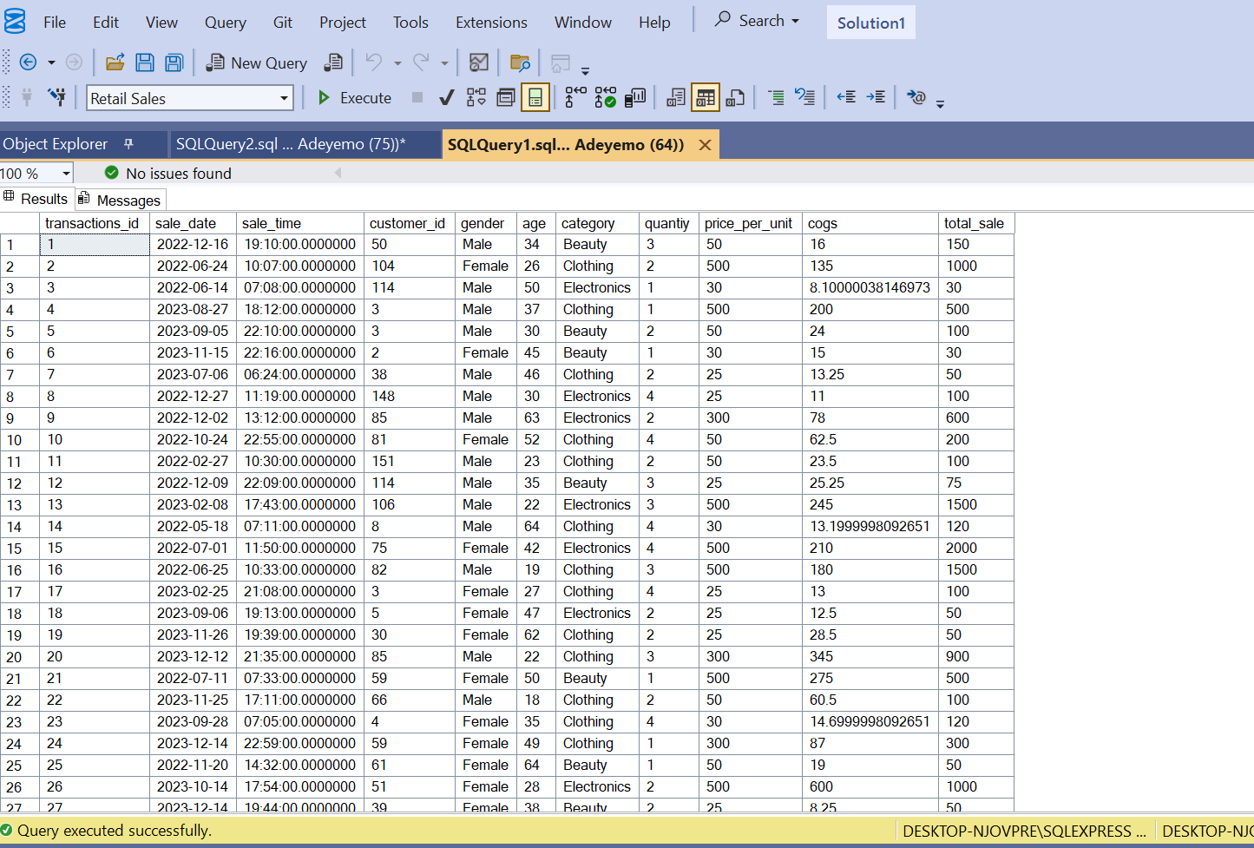

Step 3: SQL Queries
i. Sales made on 2022-11-05
select total_sale from RetailSales
where sale_date = '2022-11-05';
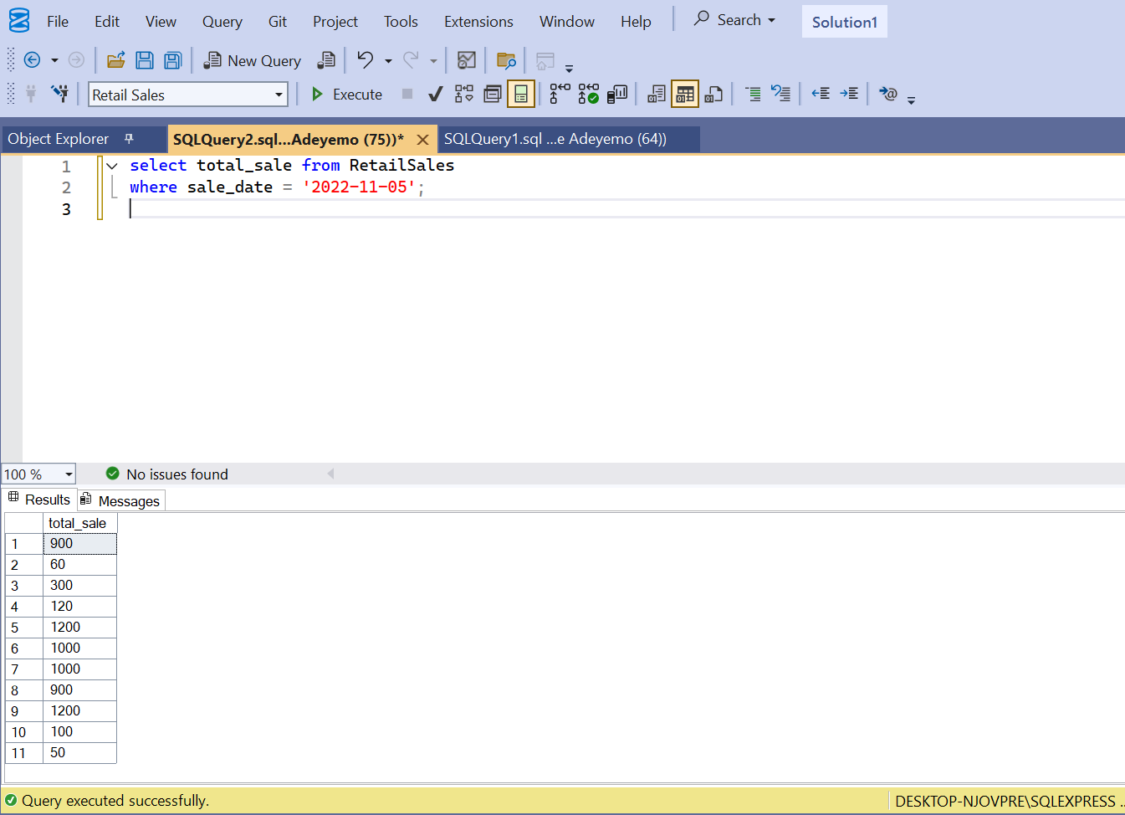
ii. Clothing sales, quantity > 4, Nov-2022
--sql
SELECT *
FROM RetailSales
WHERE category = 'Clothing'
AND quantity > 4
AND sale_date >= '2022-11-01'
AND sale_date < '2022-12-01';
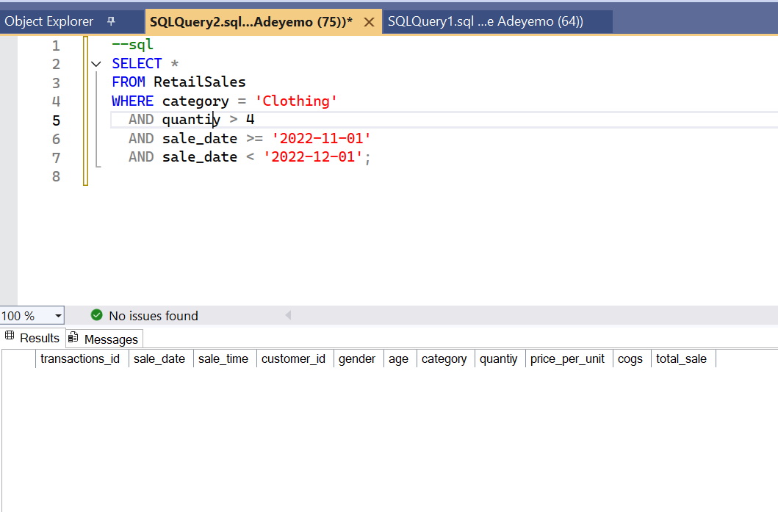

iii. Total sales for each category
--sql
SELECT category, SUM(total_sale) AS total_sales
FROM RetailSales
GROUP BY category;
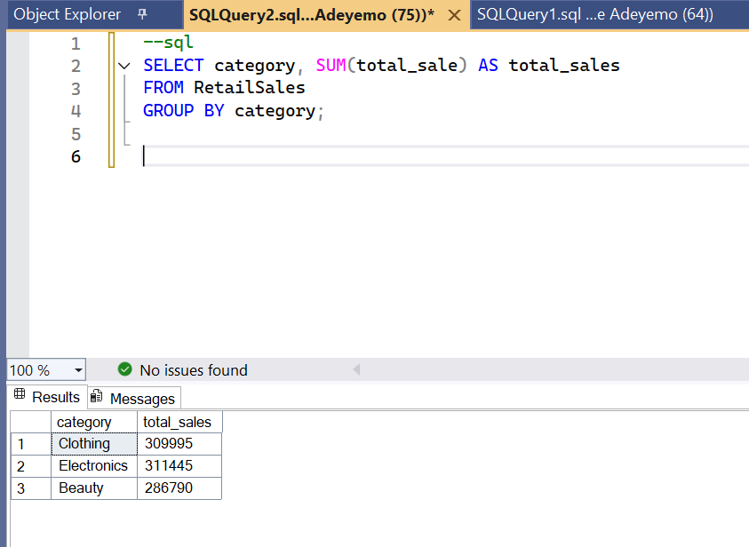

iv. Average age of customers in Beauty category
--sql
SELECT AVG(age) AS avg_age
FROM RetailSales
WHERE category = 'Beauty';
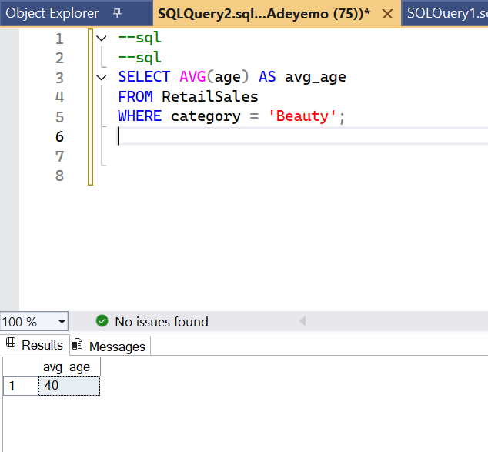

v. Transactions where total_sale > 1000
--sql
SELECT *
FROM RetailSales
WHERE total_sale > 1000;
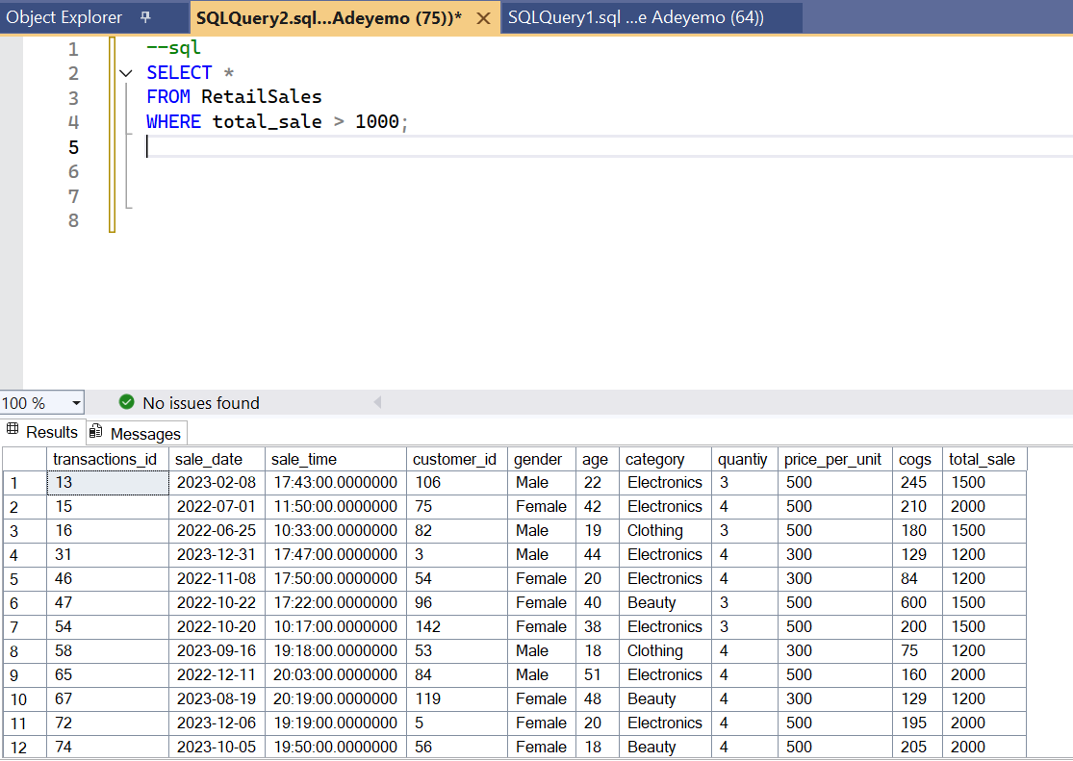
vi. Number of transactions by gender in each category
--sql
SELECT category, gender, COUNT(transaction_id) AS transaction_count
FROM RetailSales
GROUP BY category, gender;

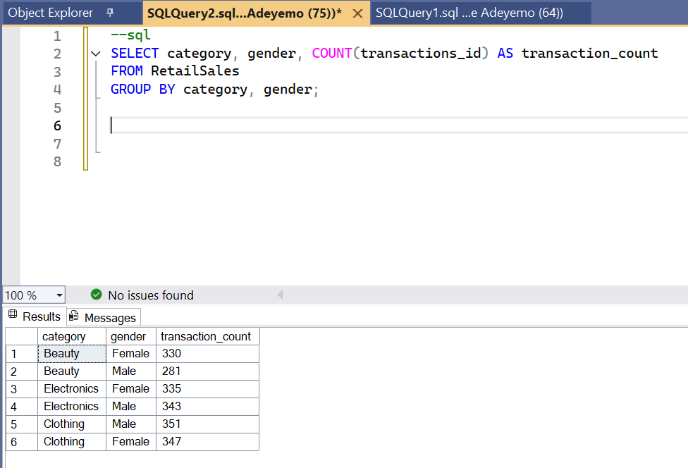
vii. Average sale per month
--sql
SELECT
YEAR(sale_date) AS year,
MONTH(sale_date) AS month,
AVG(total_sale) AS avg_sale
FROM RetailSales
GROUP BY YEAR(sale_date), MONTH(sale_date)
ORDER BY year, month;
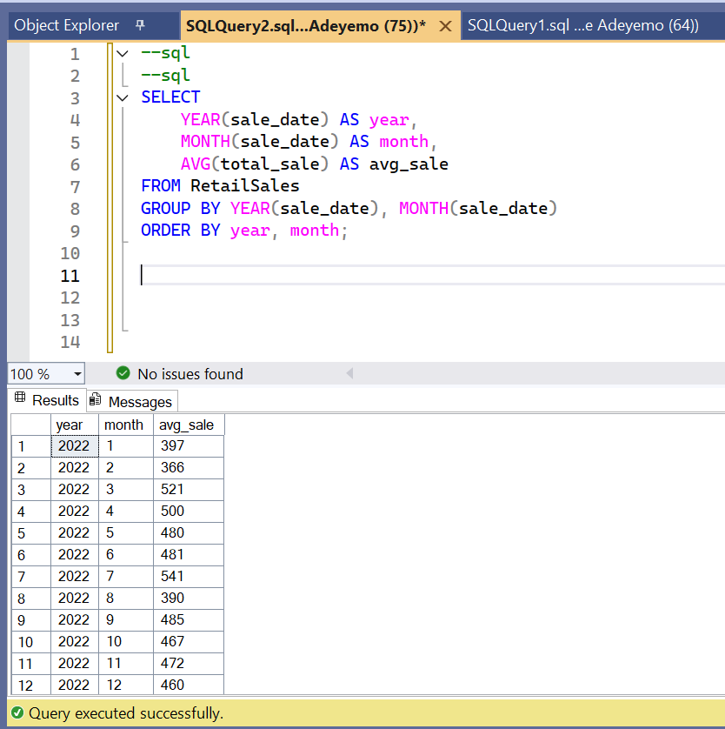

--Best-selling month each year
--sql
WITH MonthlySales AS (
SELECT
YEAR(sale_date) AS year,
MONTH(sale_date) AS month,
SUM(total_sale) AS total_sales
FROM RetailSales
GROUP BY YEAR(sale_date), MONTH(sale_date)
)
SELECT *
FROM MonthlySales ms
WHERE total_sales = (
SELECT MAX(total_sales)
FROM MonthlySales
WHERE year = ms.year
);
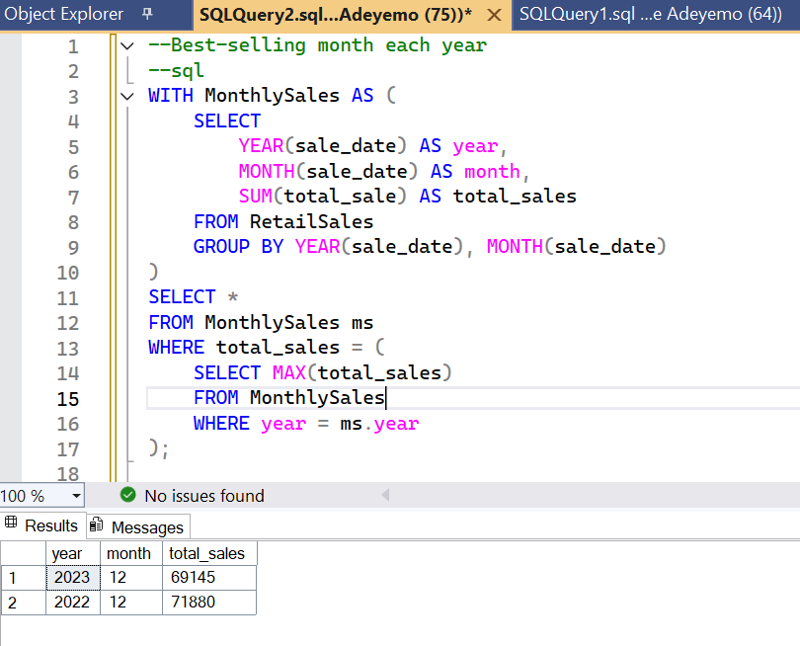
viii. Top 5 customers by total sales
--sql

SELECT TOP 5 customer_id, SUM(total_sale) AS total_spent
FROM RetailSales
GROUP BY customer_id
ORDER BY total_spent DESC;
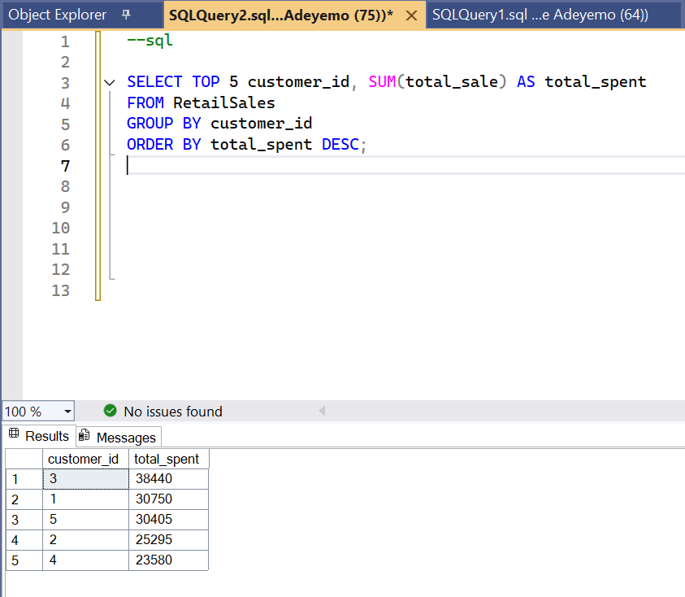

ix. Number of unique customers per category
--sql
SELECT category, COUNT(DISTINCT customer_id) AS unique_customers
FROM RetailSales
GROUP BY category;
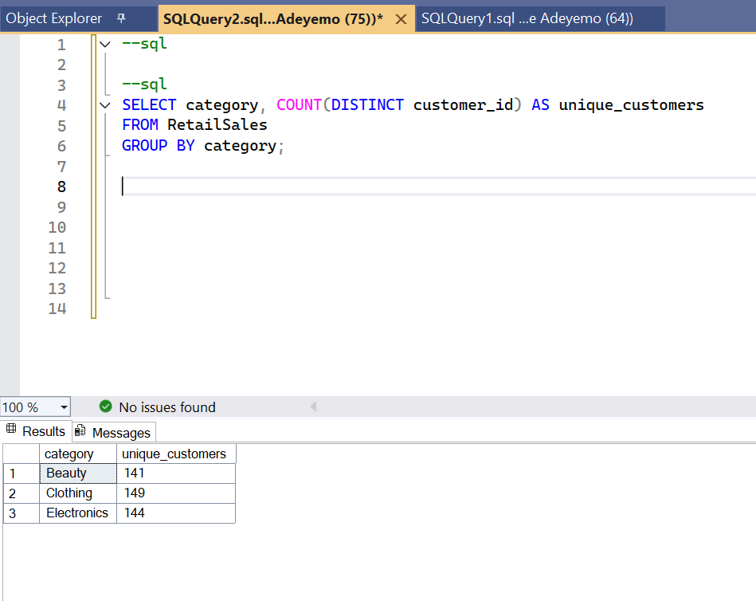

x. Number of orders by shift
SELECT
CASE
WHEN DATEPART(HOUR, CAST(sale_date AS DATETIME)) < 12 THEN 'Morning'
WHEN DATEPART(HOUR, CAST(sale_date AS DATETIME)) BETWEEN 12 AND 17 THEN 'Afternoon'
ELSE 'Evening'
END AS shift,
COUNT(transactions_id) AS orders
FROM RetailSales
GROUP BY
CASE
WHEN DATEPART(HOUR, CAST(sale_date AS DATETIME)) < 12 THEN 'Morning'
WHEN DATEPART(HOUR, CAST(sale_date AS DATETIME)) BETWEEN 12 AND 17 THEN 'Afternoon'
ELSE 'Evening'
END;
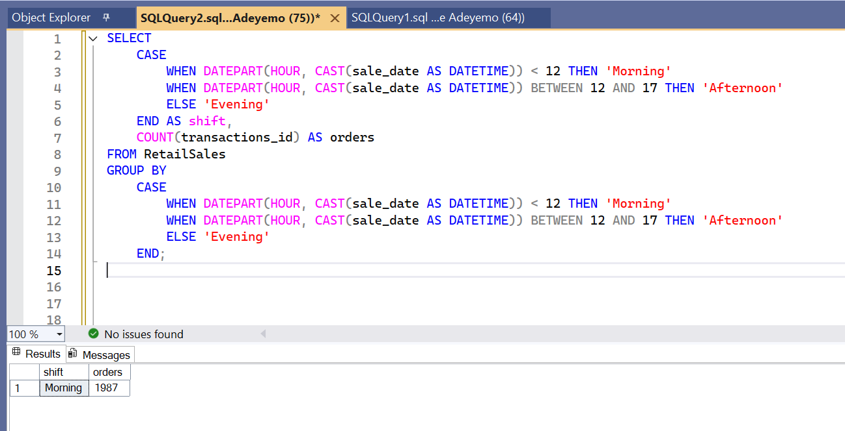

Step 4: Conclusion
- The dataset was successfully imported into SQL Server.
- Data cleaning handled missing values and removed incomplete records.
- All queries were executed successfully to extract insights, including:
  - Sales by date, category, and quantity
  - Best-selling months
  - Top customers
  - Customer demographics by category
  - Transaction patterns by shift

